Exercise 8: Time-Series Architecture
Week: 8 (Hands-On Laboratory Exercise)
Objective: To provision a MongoDB Atlas cloud cluster, architect a specialized Time-Series collection, and configure Node-RED to transform raw asynchronous MQTT payloads into strictly formatted time-series documents for persistent cloud storage.

Theory Brief: The Time-Series Database (TSDB) Paradigm
Standard databases (both SQL and NoSQL) are designed to store discrete entities (like Users or Products). However, IoT sensors generate data differently: they produce continuous, immutable streams of readings over time. If a sensor pings every 1 second, it generates 31 million documents a year. A standard database will crash trying to index this volume.
MongoDB solves this using the Bucket Pattern. When you designate a collection as "Time-Series," MongoDB stops saving every reading as an individual document on the hard drive. Instead, it groups sequential readings from the same sensor into a single, compressed "Bucket" document. To the developer, it looks like you are inserting normal JSON. But to the server, it is highly compressed, mathematically optimized, and automatically indexed.

Step 1: Architecting the Time-Series Collection in Cloud
We will now move our database architecture to a production-ready cloud environment using MongoDB Atlas.
- Configure the Time-Series Collection: Name the collection: environment_telemetry.
  - CRITICAL: Check the box that says Time-Series.
  - You must now define the schema rules:
    - Time Field: Type timestamp (This tells Atlas which key holds the chronological data).
    - Meta Field: Type sensor_id (Metadata is the static label that identifies what is generating the data).
    - Granularity: Set to Seconds (Since our ESP32 pings frequently).
  - Click Create.

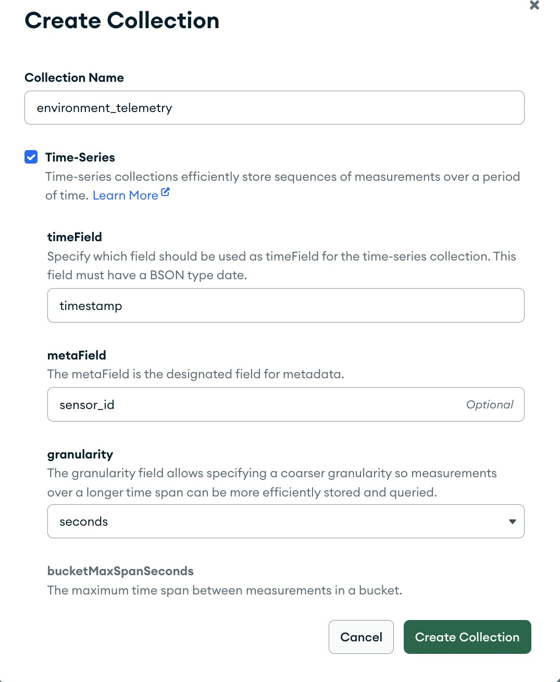

Step 2: Node-RED Middleware Transformation
Your raw ESP32 MQTT payloads (e.g., {"temperature": 25.5, "humidity": 60}) are incomplete. A TSDB strictly requires a timestamp and metadata. We must use Node-RED as middleware to append this missing architecture before it reaches the cloud.
- The MQTT Input: Drag an mqtt in node onto your Node-RED canvas. Configure it to connect to your EMQX broker and subscribe to campus/zone1/environment. Ensure the output is set to "a parsed JSON object".
- The Formatting Function: Wire the MQTT node to a function node. This node will act as our schema translator. Write the following JavaScript to construct a compliant Time-Series document:

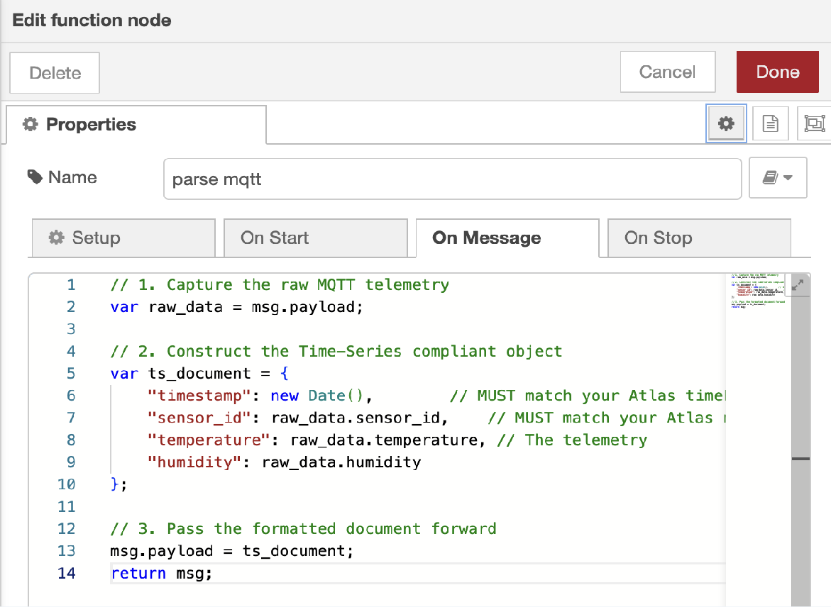

- Deploy the Ingestion Pipeline: Wire the function node to a mongodb4 node.
  - Set the URI to your MongoDB connection string.
  - Set the Operation to insertOne.
  - Target the smart_campus database and environment_telemetry collection.
- Execute: Click Deploy. Use Postman or an MQTT tool to publish raw JSON to your broker. Node-RED will intercept it, format it, and push it to the cloud.

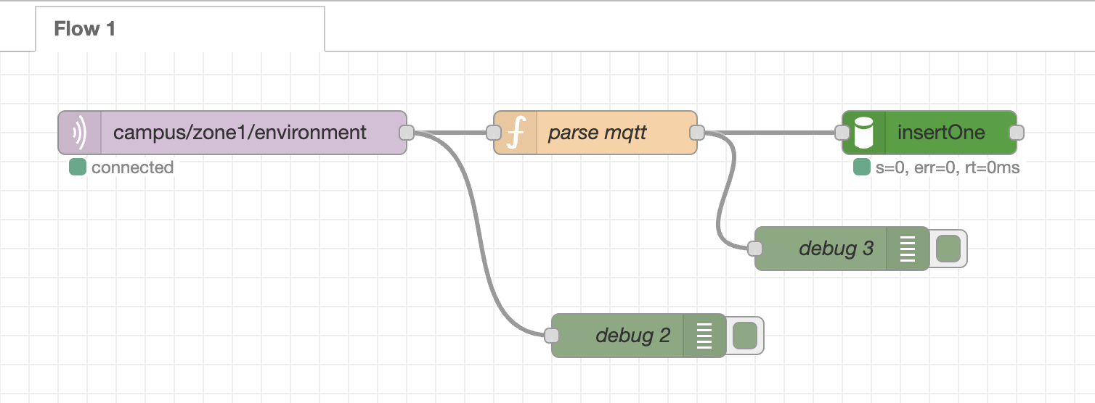

Step 3: Verifying Cloud Indexes and Bucket Storage
We must verify that the database engine actually applied the time-series mathematical optimizations.
- Verify Ingestion: Open your MongoDB Compass, browse your environment_telemetry collection, and verify the formatted JSON documents are appearing.
- Explore the Hidden Indexes: * Click the Indexes tab inside your collection.
  - You will notice MongoDB automatically created a complex Compound Index on
{ "sensor_id": 1, "timestamp": 1 }.
  - You did not write a command to create this! Because you defined sensor_id as the metaField, Atlas automatically indexed it to ensure querying historical data for a specific sensor is lighting-fast.

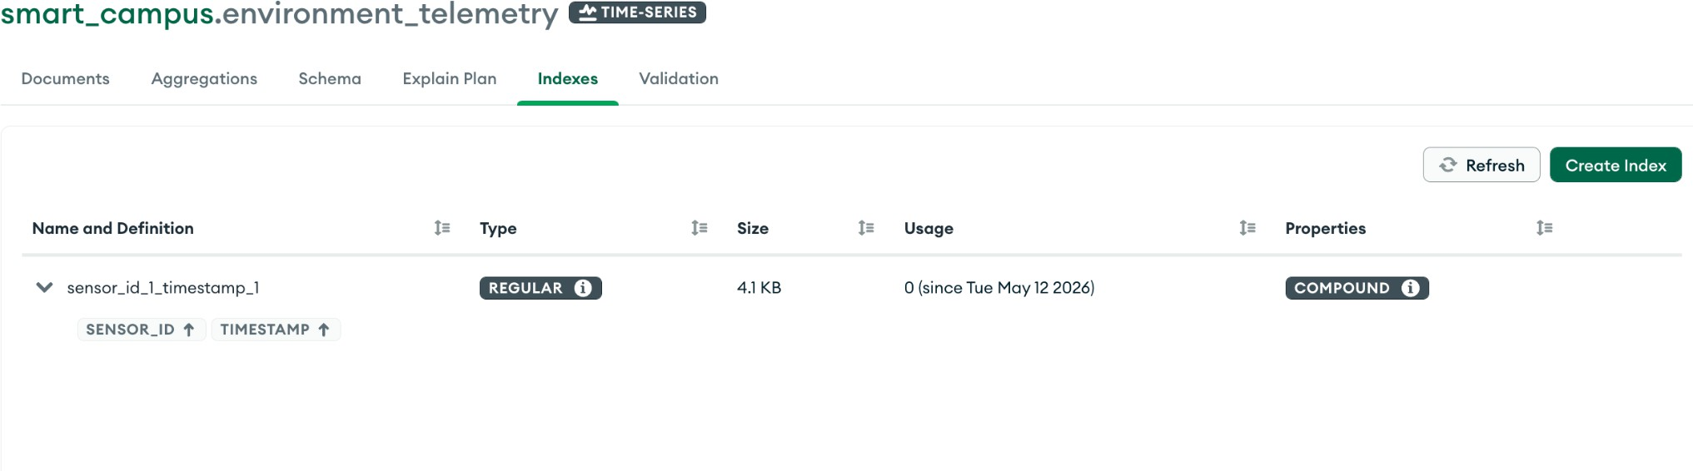

Part 4: Discussion & Architectural Analysis

Result:

NodeRed:

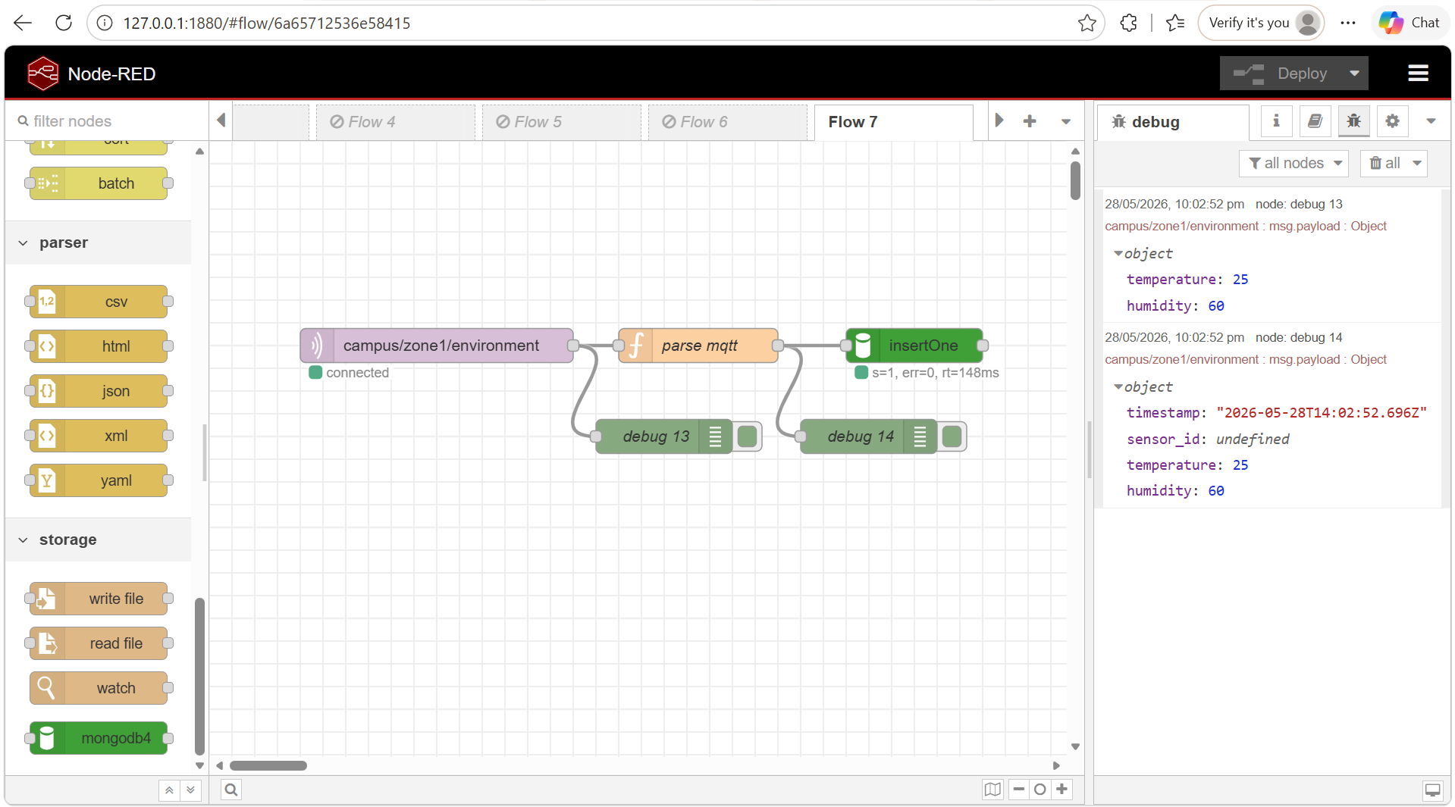

MongoDB Compass:

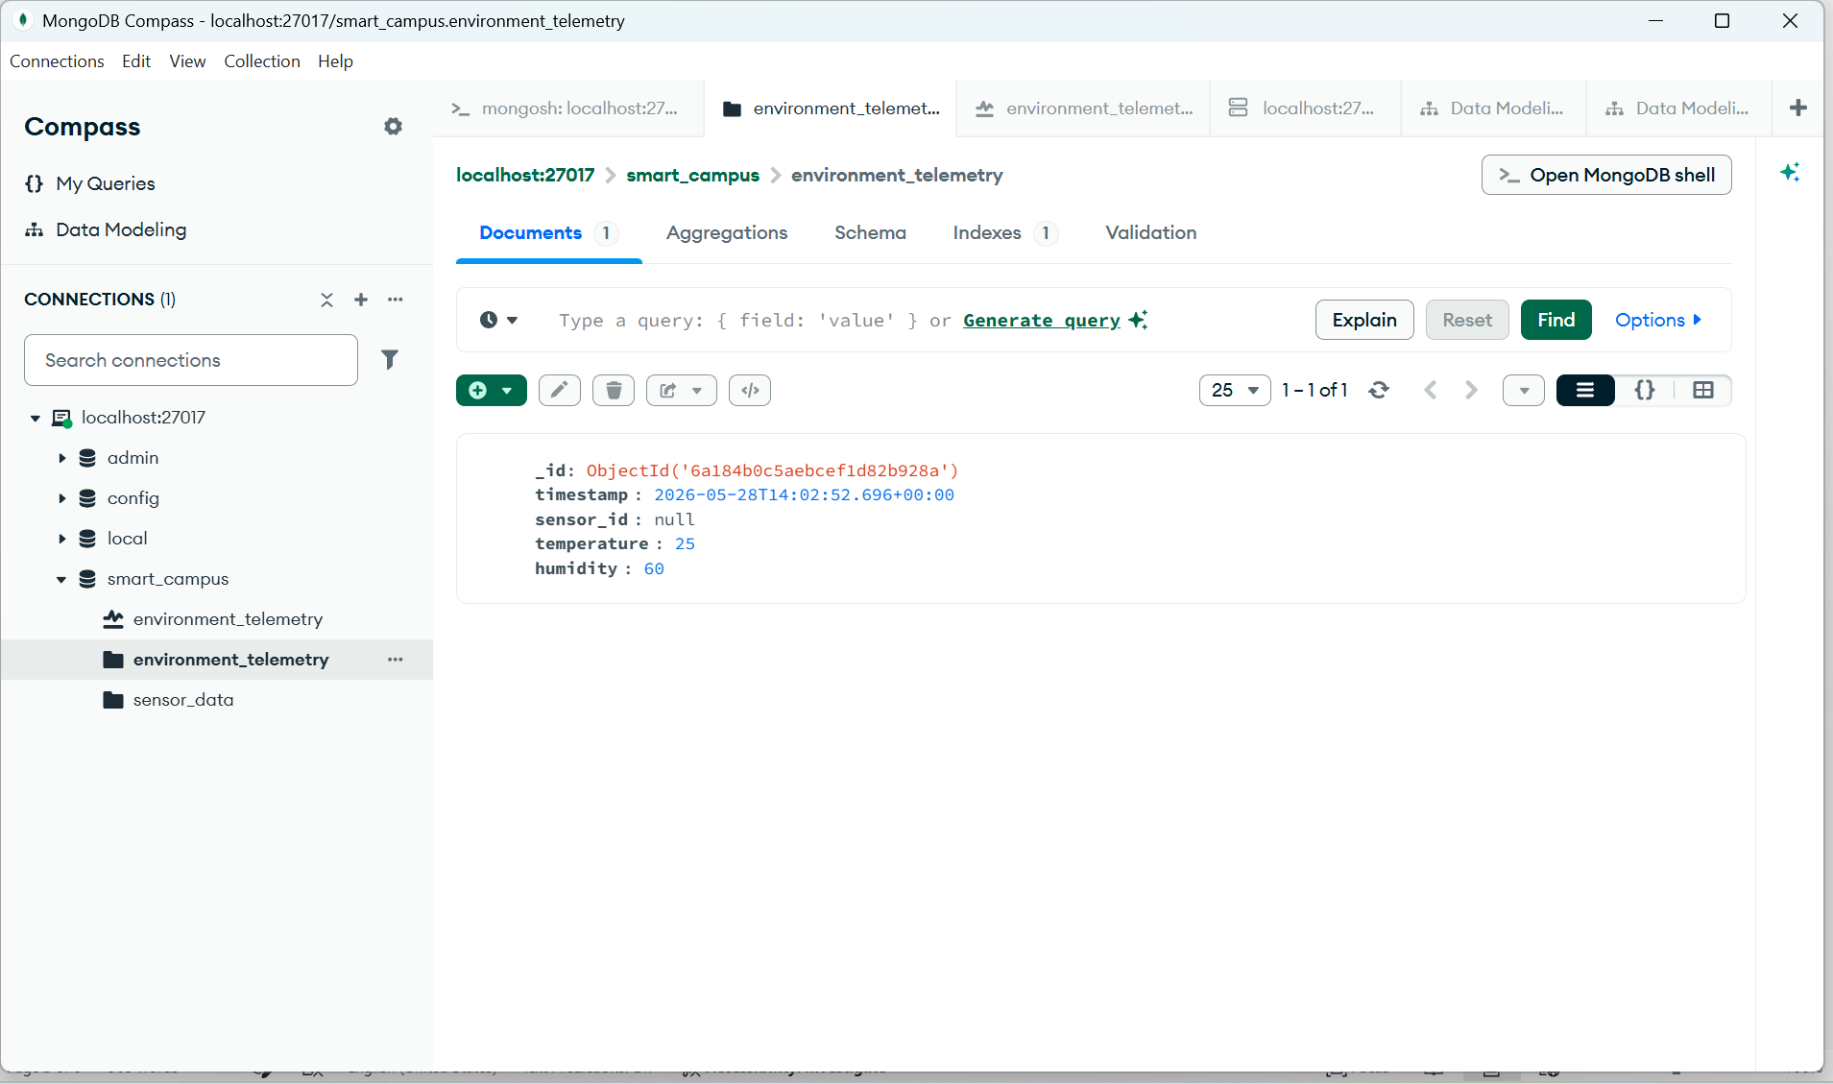

Based on your configuration of the Time-Series architecture, answer the following system engineering questions:

Question 1: The Definition of Metadata
When configuring the Time-Series collection, you explicitly set sensor_id as the metaField. Why must the metadata be a static identifier (like a MAC address, sensor name, or location) rather than the dynamic temperature reading? What would happen to the internal "Bucket Pattern" compression if you accidentally set the metaField to a variable that changes every second?
The metadata field (metaField) in a MongoDB Time-Series collection must be a static identifier such as sensor_id, MAC address, or device location because it defines the identity of the data source rather than the changing values it produces. MongoDB’s Bucket Pattern relies on grouping multiple sequential measurements from the same source into a single compressed bucket. If a dynamic value such as temperature were used as the metadata, the value would change with every reading, causing MongoDB to treat each incoming measurement as belonging to a different group. As a result, the system would continuously create new buckets instead of appending data into existing ones. This would completely defeat the purpose of time-series optimization by reducing compression efficiency, increasing storage usage, and significantly degrading query performance since historical data would be fragmented across many small buckets instead of being efficiently grouped by sensor.

Question 2: Middleware vs. Edge Timestamping
In Step 2, you used a Javascript new Date() function inside Node-RED to stamp the exact time the message arrived at the server. Why is this server-side timestamping generally safer and more accurate than having the $5 ESP32 microcontroller generate the timestamp and send it inside the MQTT payload? (Hint: Consider the hardware limitations of microcontrollers regarding Real-Time Clocks (RTC) and battery loss).
Server-side timestamping using new Date() in Node-RED is generally more reliable and accurate than generating timestamps on an ESP32 microcontroller because the server maintains a stable and synchronized system clock, whereas low-cost microcontrollers often suffer from hardware limitations. Many ESP32 devices either lack a dedicated Real-Time Clock (RTC) or rely on software-based timekeeping that can drift over time. Additionally, if the device loses power or resets, it may lose its correct time unless it reconnects to an NTP server, which introduces further delay and dependency on network availability. In contrast, timestamping at the middleware level ensures that all incoming data is recorded using a consistent and trusted time source, representing the actual arrival time at the server. This improves data integrity, ensures synchronization across multiple devices, and avoids inconsistencies caused by device-level clock drift or power interruptions.

